**HOMEWORK – 5**

PROJECT MANAGEMENT

Instruction: Create document to design question below.  
  
**1- Why we need to do sprint planning?**

We need to do sprint planning because sprint planning is to define what can be delivered in the sprint and how that work will be achieved. Sprint planning is done in collaboration with the whole scrum team.​

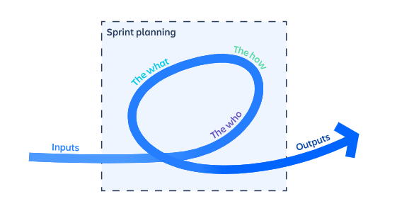

**2- Why we need to do stand up meeting?**

We need to do stand up meeting because we need information about developer and ask them about some questions such as what did they do yesterday, what are they going to do for today, and the last one what problems did they meet yesterday during do project to make sure they know their tasks and know about error that they have met. Especially, make sure they limit time to do tasks effectively.

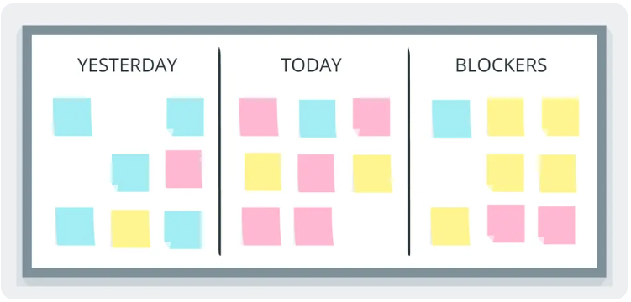

**3- Why we need to do sprint retrospective?**

We need to do a sprint retrospective because we need to find what we have done with the last sprint and ask members with three questions such as what the good things that we had done, what we need to improve, and what are the solutions for to improve. Especially we need to find bad points and improve in the new sprint to make sure that we don’t make the same mistakes again.

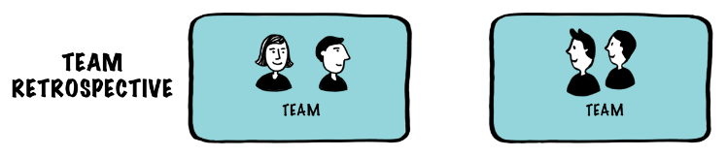

**4- Why we need to do sprint review?**

We need to do a sprint review because we need to make meetings with customer, scrum master, developer and others to protect risks of Customer dissatisfaction and ask customers for feedback for the product. Especially avoid doing projects again.

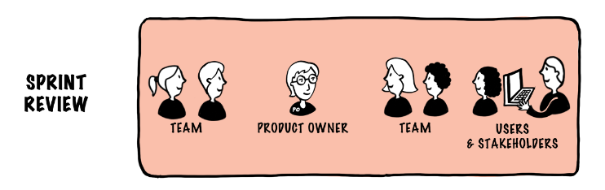

**5- Why we need to separate project in to sprint?**

We need to separate projects to sprint because we need to know about how many sprints to achieve the project. How many hours we should spend in one sprint, divide some tasks, and sub tasks into each sprint. Especially, make each sprint effectively.

